Health and Safety in the Paint shop
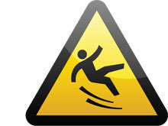

Hazards to be aware of:

- Slips on wet paint: It is easy to spill paint or kick over buckets. Maintain good housekeeping with buckets on the trolley, if possible. If paint does spill, clean up the excess straight away and put sawdust down to prevent slippage. (Don’t pour sawdust onto a large puddle or put paper on top, which will stick to the floor.)
- If the sink overflows mop first before putting down sawdust. Sweep up the sawdust as soon as it is dry.

- Trips and slips on cables or equipment left on the floor. Maintain good housekeeping, organise the paint shop so that there are clear gangways to walk through and cover any cables with a mat.

- Obstruction in case of fire: Maintain housekeeping and leave gangways for people to pass through when set is laid out in the paint shop.

- Falls from ladders: see attached guide to safe use of ladders

- Injury through lifting: Use appropriate manual handling techniques for lifting large objects. Be mindful of any repetitive techniques, which may lead to strained muscles and take regular breaks or alter your position.

- Injury through misuse of Paint Bridge: Always follow the code of practice for the paint bridge. Make sure you are trained and understand how to operate it before use. A staff member must be present when the bridge is being used.

Use of PPE:

- Masks: always use the appropriate dust/vapour mask when spraying, sanding or working near someone who is doing a task which is creating wood dust. Use also when mixing any fine powder such as Artex or metallic powders.( Any use of cellulose sprays must take place in the spray booth in the Props department which has the appropriate extraction.)

- Steel toecaps: At all times shoes worn in the paint shop should be sturdy enough to protect your feet. Steel toecaps should be worn if any scenery or large pieces are being moved.

- Latex gloves: Wear when using texture/glues or if sensitive to any paint products. See COSHH data sheets for information. Use barrier cream before painting to further protect the skin and make hands easier to clean.

- Safety goggles: Wear if using the airline stapler or for any task which involves risk to the eyes.

- Safety shoe covers: Should be used over shoes to protect a floor or a cloth if you need to walk on it after painting.

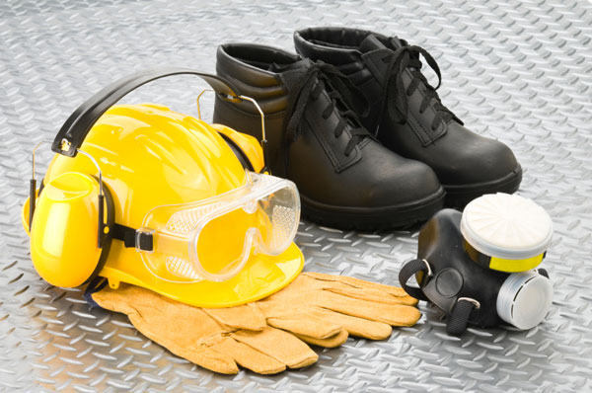

General things to note:

- Always check COSHH data sheets when using a new product to assess if PPE is needed.

- Clothing in general should be appropriate for a workshop with minimal jewellery

- iPods should not be used as they prevent the wearer from hearing if a warning is shouted.

