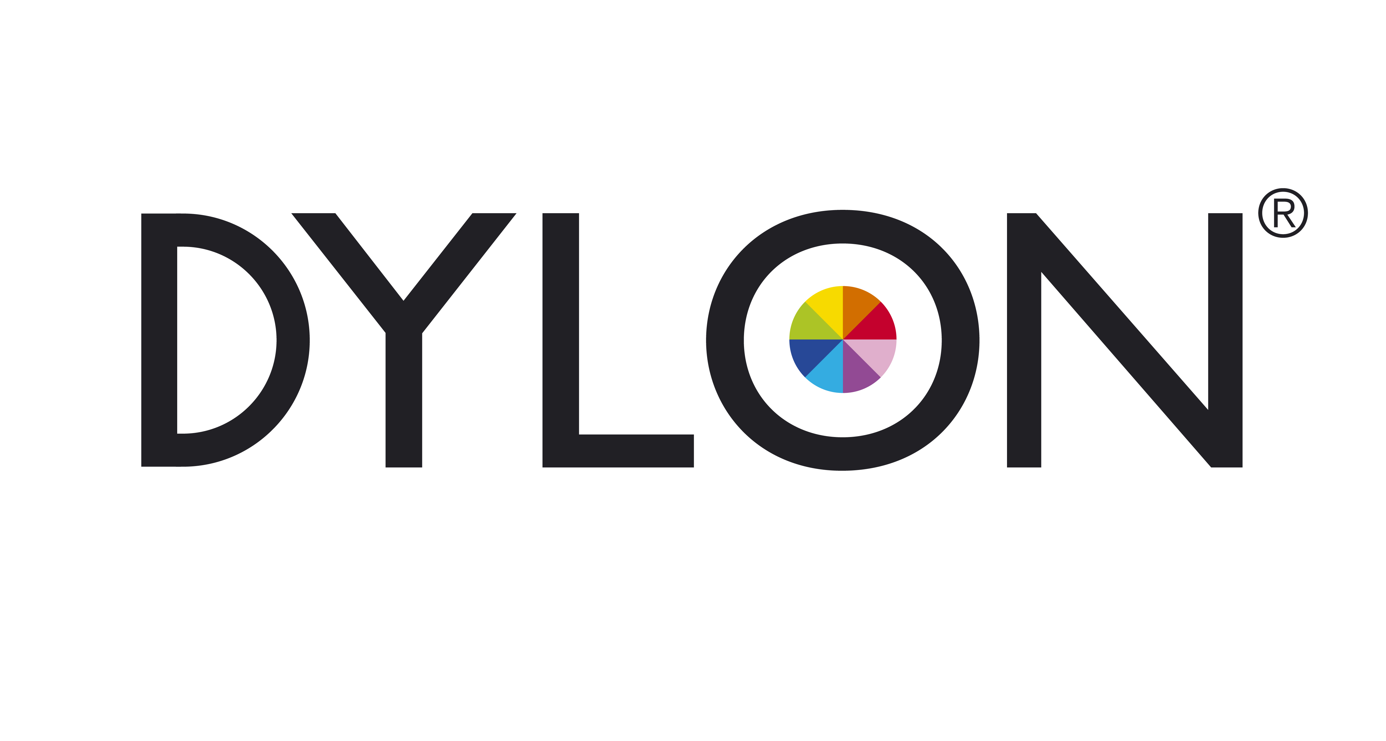
MATERIAL SAFETY DATA SHEET

_________________________________________________________________________________________________________

1. IDENTIFICATION OF THE SUBSTANCE/PREPARATION AND OF THE COMPANY

1.1 Product Identification: Dylon Multi-Purpose Dye Nos 1 – 65
Pack Size: 4.5 & 5.5 g tinlets.
1.2 Product use: Domestic dyestuff for fabrics.
1.3 Company Identification: Dylon International Ltd
WORSLEY BRIDGE ROAD
LOWER SYDENHAM
LONDON SE26 5HD

UNITED KINGDOM

TEL (+ 44) 020 8663 4801

FAX (+ 44) 020 8658 6735
E-MAIL DylonInt@dylon.co.uk

1.4 Emergency Telephone No: 0870 600 6266
_________________________________________________________________________________________________________

2. composition/information on HAZARDOUS ingredients

Ingredient EINECS No: CAS No: Concentration Range Classification

C.I. Direct Black 22 229-326-3 6473-13-8 1 – 20 % Xi: Irritant R36
(MP8 & MP21 only)

C.I. Acid Red 88 216-760-3 1658-56-6 1 – 20 % Xi: Irritant R36
(MP5, 9, 32 and 44 only)

C.I. Acid Orange 116 --- 12220-10-9 1 – 5 % R52/53
(MP34 Only)

C.I. Acid Blue 25 229-068-1 6408-78-2 5 – 20 % R52/53
(MP26 & MP34 Only)

C.I. Acid Blue 80 224-748-4 4474-24-2 1 – 5 % R52/53
(MP17 Only)

C.I. Acid Blue 113 222-111-5 3351-05-1 1 – 10% N: R51/53
(MP17, MP19, MP26 & MP62 only)

C.I. Acid Green 25 224-546-6 4403-90-1 5 – 15 % R52/53
(MP25 & MP62 Only)

C.I. Acid Violet 17 223-942-6 4129-84-4 1 – 5 % R52/53
(MP15 & MP16 Only)

C.I. Acid Brown 283 274-491-7 70236-61-2 15 – 25 % R52/53
(MP7 Only)
_________________________________________________________________________________________________________

3. HAZARDS IDENTIFICATION

No significant hazard.
_________________________________________________________________________________________________________

_________________________________________________________________________________________________________

4. FIRST AID MEASURES (SYMPTOMS & ACTION)

Eye contact Contact with eyes may cause slight irritation.
Promptly rinse eyes with plenty of water for 15 Minutes.
Skin contact Contact with skin may cause slight irritation.
Wash skin thoroughly with soap and water.
Inhalation High dust concentrations may cause coughing and wheezing.
Remove exposed person to fresh air. Should any symptoms persist, seek medical advice.
Ingestion Ingestion may cause irritation to the digestive tract, diarrhoea and nausea.
Do not induce vomiting. Rinse mouth out with water. Drink plenty of milk or water. In the event of significant ingestion or if any symptoms persist, seek medical advice.
_________________________________________________________________________________________________________

5. FIRE FIGHTING MEASURES

Extinguishing Media Use extinguishing media appropriate to surrounding fire.
Exposure Hazards May form flammable dust / air mixture.
Protective Equipment Wear full protective clothing and self-contained breathing equipment.
_________________________________________________________________________________________________________

6. ACCIDENTAL RELEASE MEASURES

Take precautions to avoid creating and breathing dust (see section 8). Absorb any spilled material immediately onto inert material i.e. sand or vermiculite and transfer into labelled containers for disposal (see section 13). Small spillages may be flushed away with copious amounts of water.
_________________________________________________________________________________________________________

7. HANDLING AND STORAGE

Handling When handling this product, observe good standards of industrial hygiene to avoid swallowing, inhaling dust and eye or skin contact by the use of suitable personnel protective equipment (PPE). It is advisable always to wear hand protection when handling chemicals.
Storage Store in a cool, dry, well-ventilated area.
_________________________________________________________________________________________________________

8. EXPOSURE CONTROLS/ PERSONAL PROTECTION

  - Exposure Limit Values No Workplace Exposure Limits have been assigned to the individual components
of this product. In the absence of a specific limit, dust concentrations should be controlled and kept below
the following limits:

WES (UK) Long term 8 hr TWA Short term 15 min ref. period
ppm mg/m³ ppm mg/m³
Total inhalable dust --- 10 --- ---
respirable dust --- 4 --- ---

8.2 Exposure Controls
Respiratory Protection None required under normal i.e. domestic use. Wear a suitable mask if handling is
likely to raise dust. This product should be weighed under conditions of Local
Exhaust Ventilation (LEV).
Hand Protection Wear rubber or chemical resistant gloves.
Eye Protection None required under normal use. Where large amounts are being handled, wear
chemical resistant safety glasses or goggles.
Eyebaths should be provided at places where accidental exposure may occur.
Skin Protection None required under normal use.
_________________________________________________________________________________________________________

_________________________________________________________________________________________________________

9. PHYSICAL AND CHEMICAL PROPERTIES

Appearance Coloured powder
Odour Barely perceptible
pH 7 – 9 (10 g/l)
Solubility – Water Highly soluble
_________________________________________________________________________________________________________

10 STABILITY AND REACTIVITY

Stable under normal and intended uses and applications. Hazardous polymerisation will not occur.

Conditions to avoid None known.
Materials to avoid Strong acids.
Hazardous decomposition products Contact with acids liberates toxic gas.
_________________________________________________________________________________________________________

11. TOXICOLOGICAL INFORMATION

Acute Oral Toxicity LD50 value : All components >2000 mg/kg (oral, rat)
Skin Irritation Non – irritant
Eye Irritation Non – irritant
_________________________________________________________________________________________________________

12. ECOLOGICAL INFORMATION

C.I. Acid Orange 116 LC50 10 - 100 mg/l. [48hr, Rainbow Trout]
C.I. Acid Blue 25 LC50 32 mg/l. [48hr, Rainbow Trout]
C.I. Acid Blue 80 LC50 Approx. 75 mg/l. [48hr, Rainbow Trout]
C.I. Acid Blue 113 LC50 1 – 10 mg/l. [96hr, Rainbow Trout].
C.I. Acid Violet 17 LC50 10 – 100 mg/l. [48hr, fish].
C.I. Acid Green 25 LC50 14.3 mg/l. [96hr, Guppies].
C.I. Acid Brown 283 LC50 16 mg/l. [96hr, Zebra Fish].
_________________________________________________________________________________________________________

13. DISPOSAL CONSIDERATIONS

Disposal should be in accordance with all national and local authority regulations.
_________________________________________________________________________________________________________

14. TRANSPORT INFORMATION

Proper shipping name Not classified as dangerous in the meaning of transport regulations

UN Number -- IMDG / IMO --

ADR/RID -- IATA/ICAO --
_________________________________________________________________________________________________________

15. REGULATORY INFORMATION

Classified according to Directives 67/548/EEC and 1999/45/EC and their various amendments

Warning Symbols: None
Warning Words: None
Risk Phrases: None
Safety Phrases: None
_________________________________________________________________________________________________________

_________________________________________________________________________________________________________

16. OTHER INFORMATION

The information in this Safety Data Sheet is given in good faith. The information herein is accurate to the best of our knowledge and represents the most up to date information available to us. Products should be handled and used in accordance with the advice given. The information in this Safety Data Sheet does not constitute an assessment of workplace risks.

Key to R Phrases – Section 2

R36 – Irritating to eyes.
R51/53 – Toxic to aquatic organisms, may cause long term adverse effects in the aquatic environment.
R52/53 – Harmful to aquatic organisms, may cause long term adverse effects in the aquatic environment.

Recommended uses and restrictions

This product is intended for use as a dyestuff for fabrics as per the instruction leaflets/labels.

Abbreviations:

CAS = Chemical Abstract Service (Section 2)
C.I. = Colour Index (Section 2)
EINECS = European Inventory of Existing Commercial Chemical Substances (Section 2)
LC = Lethal Concentration (Section 12)
LD = Lethal Dose (Section 11)
TWA = Time Weighted Average (Section 8)
WES = Workplace Exposure Standard (Section 8)

Revision Details: Replaces Issue MPD 01 Rev. no. 7 dated 23.01.2007. _________________________________________________________________________________________________________

