 |  |  | COSHH Assessment Form
Product name & Manufacturer |  |  |  | Artex Textured finish- Artex limited
Stored |  |  |  | Paintshop – Yellow Flammable cupboard
Storage Instructions |  |  |  | Restricted access  Store in cool dry place
Fire Fighting Measures |  |  |  | Appropriate measures for the environment
Process/Appearance |  |  |  | White,grey or pink powder
Where is Product used |  |  |  | Paint shop area
When is product used |  |  |  | During working hours 07:00-22:00 Mon-Sun
Identify the persons at risk: |  |  |  |  | Employees  X |  |  | Contractors |  | Students  X
Classification (state the category of danger)


Toxic
Extremely Flammable

Irritant

Very Toxic

Sensitising

Highly Flammable

Biological
Flammable


Corrosive

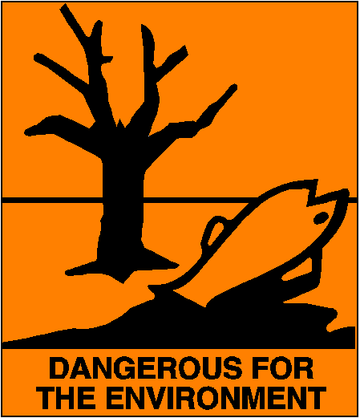
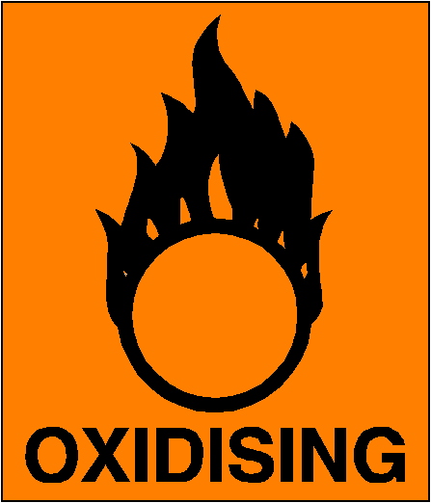

Environmental
Oxidising
Harmful

Hazard Type
X

Gas Vapour Mist Fume Dust Liquid Solid Other (State)
Route of Exposure

X

Inhalation Skin Eyes Ingestion Other (State)
Control Measures: (for example extraction, ventilation, training, supervision). Include special measures for vulnerable groups, such as disabled people and pregnant workers. Take account of those substances that are produced from activities undertaken by another employer’s employees.
See Safety Data sheet for more information

Personal Protective Equipment (state type and standard)
X  Dust mask |  |  |  |  |  |  | Visor
Respirator |  |  |  |  |  |  | Goggles
Gloves |  |  |  |  |  |  | Overalls
Footwear |  |  |  |  |  |  | Other
First Aid Measures
X  Ingestion |  | No special treatment
X  Skin |  | Normal hand washing
X  Eyes |  | Material in eyes should be rinsed out using an eye wash bottle or copious amounts of water, seek medical attention.
X  Inhalation |  | Where dust is inhaled, remove to fresh air and seek medical advice.
Is exposure adequately controlled? |  |  |  |  |  | X  Yes No

Assessed by: Elliott Barnes Position: Facilities Manager Date: 29.7.11

