 |  |  | COSHH Assessment Form
Product name & Manufacturer |  |  |  | Bronze Powders-Wolstenholme Limited
Stored |  |  |  | Paintshop– Yellow Flammable cupboard
Storage Instructions |  |  |  | Restricted access  Keep away from heat, direct sunlight and sources of ignition
Fire Fighting Measures |  |  |  | Appropriate measures for the environment  Do not use water jet
Process/Appearance |  |  |  | Gold coloured powder
Where is Product used |  |  |  | Paint shop area
When is product used |  |  |  | During working hours 07:00-22:00 Mon-Sun
Identify the persons at risk: |  |  |  |  | Employees  X |  |  | Contractors |  | Students  X
Classification (state the category of danger)


Toxic
Extremely Flammable

Irritant

Very Toxic

Sensitising

Highly Flammable

Biological
Flammable


Corrosive


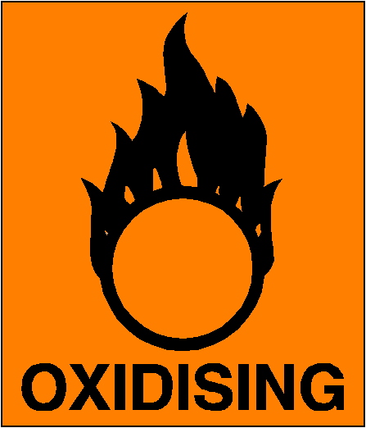

Environmental
Oxidising
Harmful

Hazard Type
X

Gas Vapour Mist Fume Dust Liquid Solid Other (State)
Route of Exposure
X

X

Inhalation Skin Eyes Ingestion Other (State)
Control Measures: (for example extraction, ventilation, training, supervision). Include special measures for vulnerable groups, such as disabled people and pregnant workers. Take account of those substances that are produced from activities undertaken by another employer’s employees.
See Safety Data sheet for more information

Personal Protective Equipment (state type and standard)
Dust mask |  |  |  |  |  |  | Visor
X  Respirator |  |  |  |  |  |  | Goggles
X  Gloves |  |  |  |  |  |  | Overalls
Footwear |  |  |  |  |  |  | Other
First Aid Measures
X  Ingestion |  | Rinse mouth throughly, do not induce vomiting. Seek medical attention.
X  Skin |  | Rinse with plenty of water, seek medical attention if symptoms persist.
X  Eyes |  | Rinse with water for 15 mins, seek medical attention
X  Inhalation |  | Remove to fresh air, seek medical attention.
Is exposure adequately controlled? |  |  |  |  |  | X  Yes No

Assessed by: Elliott Barnes Position: Facilities Manager Date: 29.7.11

