Manual Handling September 2021

In this lesson we will cover

* define Manual Handling
* Your responsibilities
* Guildhalls responsibilities to you
* Your Anatomy
* Types of injury that can be caused by poor manual Handling
* Principles of safe Handling
* Mechanics of Movement

What is Manual handling?

Manual Handling is anything that involves the application of bodily force to an object

* Lifting and Lowering
* Holding and Carrying
* Pushing and Pulling
* Throwing
* Other?

We will give examples of these actions that you may encounter at Guildhall

Your responsibilities

It is vital that you decide for yourself how to carry out any handling tasks, in many cases this will be to follow the instructions or codes of practice

* You need to be aware of and recognise your own limitations
* If you have any existing injuries or feel unable to do any practical task you must make whoever is supervising you know about them.
* If people are made aware they have a responsibility to act on the information
* If they are not made aware you may be liable for any damage.
* **Listen to your body** be aware of tiredness and in some cases Pain
* Put your training into practice at Guildhall, and at Home, and if you are working elsewhere
* Don’t put others at risk
* Report shortcomings and make suggestions.

The Law

Manual handling is covered by

* The Health and safety at work act 1974
* The management of Health and Safety Regulations 1999
* The Manual handling Operations Regulations 1992

The health and safety at work acts emphasis is unsurprisingly about building in safety so you should have

Safe plant and equipment

Safe systems of work

Employers must provide a safe working environment and training in manual handling and safe working

The Manual Handling Regs 1992 establish a hierarchy of measures for dealing with risks from manual handling

**Avoid** hazardous manual handling operations so far as reasonably practicable

**Assess** any hazardous manual handling operations that cannot be avoided, and

**Reduce** the risk of injury so far as reasonably practicable

Employers (and therefore GSMD’s) Responsibilities

* To manage manual handling safety
* To avoid risk where possible
* To make risk assessments and keep them up to date
* To manage the risks to tolerable levels
* To train inform and supervise Staff (and students)

In summary to have the best techniques to teach the best techniques and to supervise the best techniques

Anatomy and Injury

You come equipped with a bony skeleton which is connected at the joints (of which there are different types).

Attached to the skeleton by tendons are muscles which act in opposing sets across the joints to enable you to move.

Some muscles and ligaments also act to hold the skeleton in place.

Control of the muscles is by the nervous system which can be conscious or reflex

Causes for concern

* When you apply force to something force is applied back to you.
* The further you reach the more force you have to apply and the less able your muscles are to act
* Holding a posture will lead to muscle tiredness quite quickly and may cause cramp or muscle spasm
* Repetitive actions will tire muscles leading to chance of injury

This diagram shows safe loads in various positions this is a general guide individuals may be able to manage less

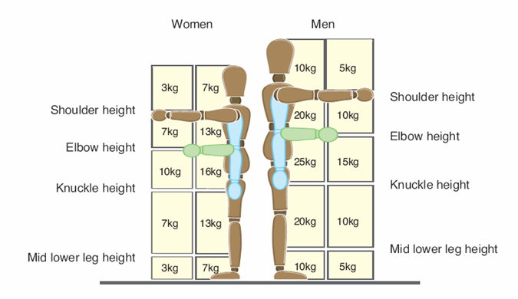

The Back

The back is the most commonly injured body part in manual handling operations; however, the same structures make up the back as the rest of the body muscles, bones, tendons, cartilage, ligaments. And they get injured in the same way

There are special back issues related to the large amount of nerves and the intervertebral discs

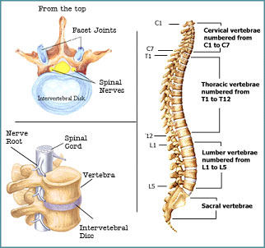

Functions of the back

Support for the head and upper body

Enclose and protect the spinal cord

Allow movement in all directions

A certain amount of movement is good as this is what it is designed to do

but if you move too far especially under load it is easy to damage

The spine has 3 curves cervical thoracic and lumbar

These act a bit like a spring to absorb shock as they are held in place by core muscles.

Your lumbar Lower back region supports most of the weight when standing (or pushing a car)

It consists of separate bones with sliding facet joints between.

The bones have ligaments connecting them each of which allows a little bit of stretch and all this adds together to make a larger overall movement.

The muscles of the back control the movement but individually are not very powerful

The spinal cord passes down a central channel but between each bone spinal nerves come in and out to spread out to the body. If they are pressed on (Impingement) or damaged it is exceedingly painful

Between the bone surfaces are the discs, which are like a jelly centre in fibrous outer layers these act as pads between the bones a bit like a tyre between the wheel and ground.

(power of a muscle is related to its cross-sectional area. So power is in big buttock thigh and calf muscles)

Power muscles give feedback quickly, deep core muscles can be damaged before you know about it

Injuries

* Most back injuries are to the muscles and ligaments only 4% are to the discs
* Most injuries build up over a period of time without us particularly noticing
* Sometimes a single event can bring the damage to light
* Rarely, perfectly healthy tissue can be damaged in a one off, possibly high impact, event

To avoid overload be careful and honest with team lifting, and maintain mid range movements in joints

It is possible to injure almost any part of your body with bad manual handling

Back injuries

As with other injuries back injuries build up over time without us noticing

They can include;

Muscle strain

Torn or stretched ligaments

Trapped compressed or impinged nerves

Disc damage

Discs wear down due to aging and lose elasticity, so the bones get closer together and the forces on the joints increase, movement is restricted and this makes you more prone to serious injury. This is not limited to old people because.

**If you misuse your back it will wear out quicker**

Slipped discs

This is where one part of the disc bulges out sideways due to a rupture in the outer fibrous layers. This often leads to pressure on a nerve causing pain.

Discs have poor blood supply and so do not heal well but can be removed or replaced in operations the best support for your back is a strong set of muscles using a back belt will lead to weakening of the muscles and should be left to the Bulgarians.

Principles of safe handling

* **Avoid**
* **Assess**
* **Plan**
* **Prepare**
* **Perform**

Avoiding, can the task be mechanised? Can you stop doing the task? can you get someone else to do it?

Assessing,

Posture is lifting necessary?

Pace of work are you doing it once or once a minute?

Is there team handling

Also assess; the individual, the load, the environment (3 groups)

Planning,

What posture to use, any mechanical equipment to help?

Preparing

Make access easier

Make the load stable

Distribute the weight evenly and move its Centre of gravity close to you

Can anyone help?

Warm up

Wear PPE

Check the route and destination

How to grip the load

Perform the task

Keep a wide base of support

Maintain the lumbar curve

Try to avoid twisting and stooping keep the load close

Get a good grip

Position feet in the direction of travel

Use smooth controlled movements

Lift as a team where appropriate

Movement issues

* Stability
* Static muscle work
* Sudden movements
* Twisting
* Uneven handling
* Pushing
* Pulling
* Overreaching
* Repetition